# Durable Furnitures

Interlude Home

## Flora Up Light Mini Pendant

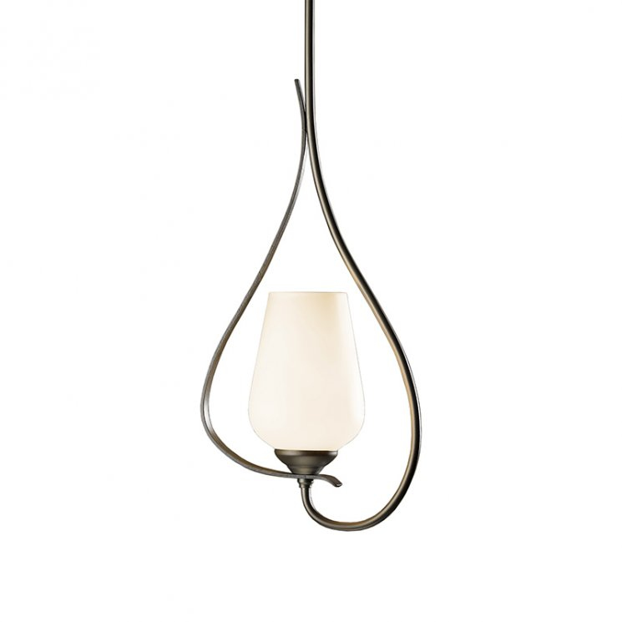

You've never experienced a natural organic design blended so perfectly with modern craftsmanship until you've gazed at the Flora Up Light Mini Pendant from Hubbardton Forge. Two delicate tendrils of hand-curved steel frame in the soft glow of an equally delicate glass shade. This designer lighting piece will soften the mood in any room with its simple meandering lines and soothing yet lively presence.